Practical - 8
Practical Title: MySQL Schema Design, ER Model, PDO Connectivity, and Prepared Statements
Design the database for StudentHub with students, events and registrations. Create PHP database connection using MYSQL statements.

Theory

1. Is the schema normalized properly?
- Database credentials are stored in a separate db.php file.
- The database connection is established using PHP and MySQL.
- Prepared statements are used to prevent SQL injection.
- User passwords should be hashed using password_hash() before storing them.
- Database credentials should not be exposed publicly.
- For production, use environment variables and HTTPS for better security.

2. Are primary keys and foreign keys correctly defined?
- Primary keys: Correctly defined to uniquely identify each record in a table. They cannot contain duplicate or NULL values.
- Foreign keys: Correctly defined to establish relationships between tables by referencing the primary key of another table.
- Conclusion: Yes, primary keys and foreign keys are correctly defined if they maintain uniqueness and referential integrity.

3. Is the database connection handled securely?
- The schema is properly normalized if it follows 1NF, 2NF, and 3NF.
- 1NF: Each column contains atomic (single) values, with no repeating groups.
- 2NF: Every non-key attribute depends on the entire primary key.
- 3NF: No non-key attribute depends on another non-key attribute.
- Redundancy: Data duplication is minimized, reducing insertion, update, and deletion anomalies.
- Conclusion: If all these conditions are satisfied, the schema is normalized up to 3NF.
Implementation/Output/Result

My learning codes: https://drive.google.com/file/d/1CPP3uUq3gdKZxC3pFB7iheZVU7FCImSx/view?usp=drive_link

Evidence of Work (Screenshots)
Table records:
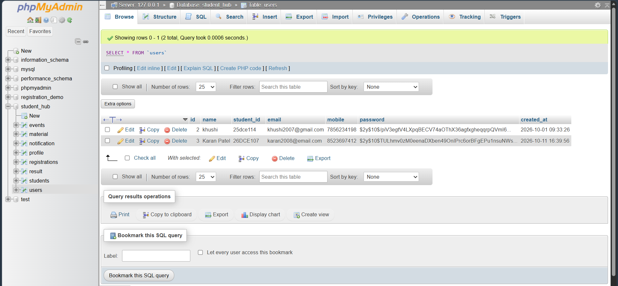
Database:
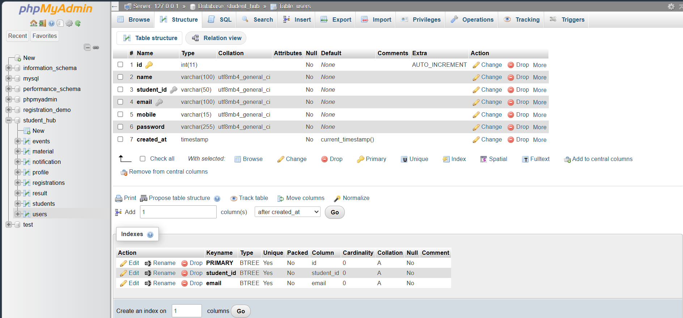

Database connection code:
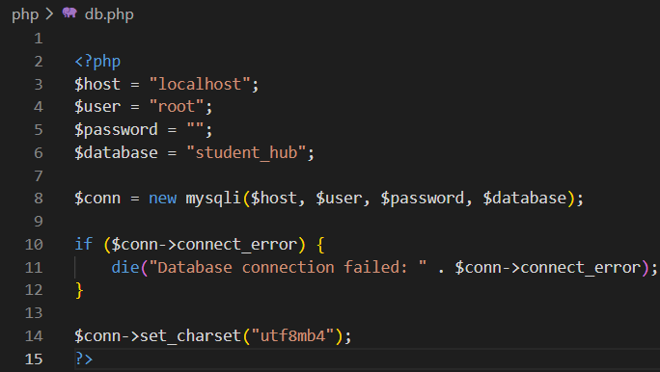

GitHub Repository Link:
Khushi-Thakor2007/Student-Hub-Portal

Challenges Faced:
- Designing the database tables and establishing relationships using primary and foreign keys.
- Connecting PHP to MySQL and using prepared statements to handle database queries securely.

Learning Outcomes:
- Learned to design a MySQL database for students, events, and registrations with proper relationships.
- Learned to connect PHP with MySQL and use prepared statements for secure database operations.

Faculty Remarks:

